Week:04-01
ROLL NO.: 241801310
Name: Vidhyashree.J
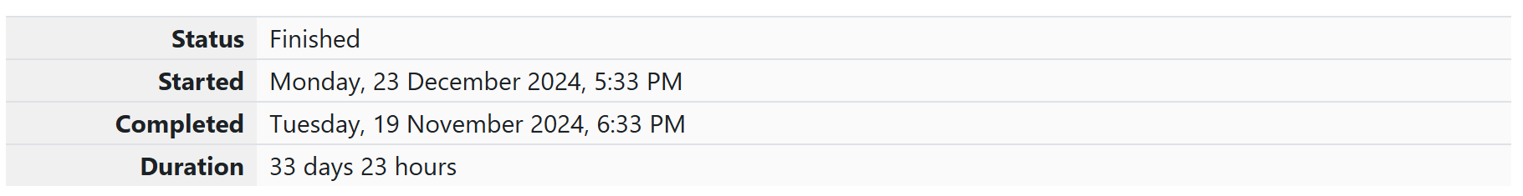
Q1) Alice and Bob are playing a game called "Stone Game". Stone game is a two-player game.
Let N be the total number of stones. In each turn, a player can remove either one stone or
four stones. The player who picks the last stone, wins. They follow the "Ladies First" norm.
Hence Alice is always the one to make the first move. Your task is to find out whether Alice
can win, if both play the game optimally.
Input Format
First line starts with T, which is the number of test cases. Each test case will contain N
number of stones.
Output Format
Print "Yes" in the case Alice wins, else print "No".
Constraints 1<=T<=1000 1<=N<=10000
Sample Input
3
1
6
7
Sample Output
Yes
Yes
No
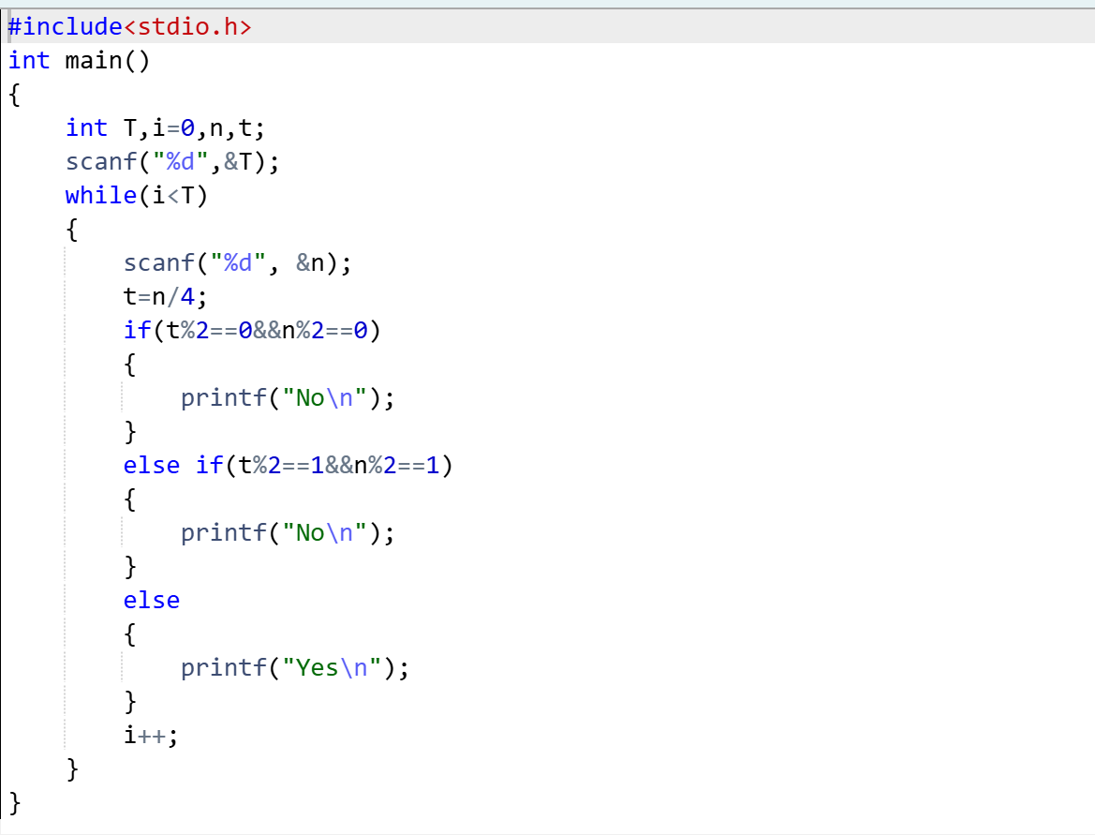
OUTPUT:
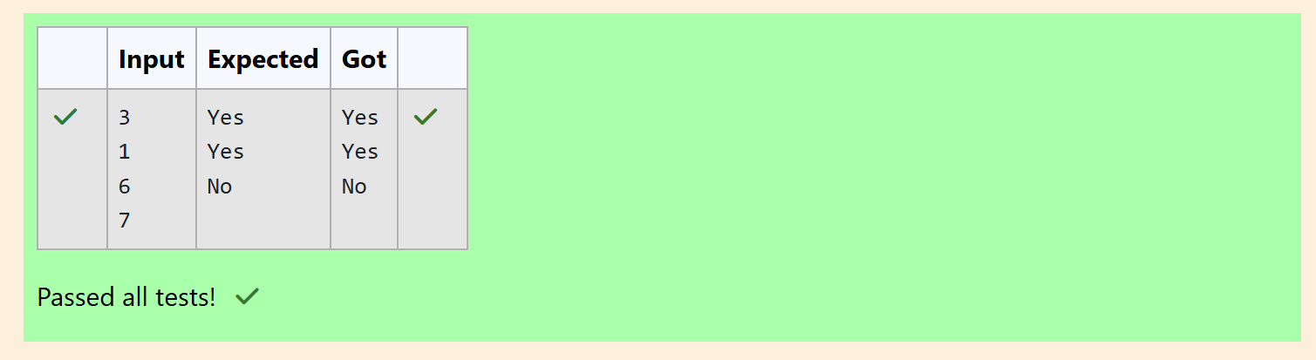

Q2) You are designing a poster which prints out numbers with a unique style applied to each
of them. The styling is based on the number of closed paths or holes present in a given
number.
The number of holes that each of the digits from 0 to 9 have are equal to the number of
closed paths in the digit. Their values are:
1, 2, 3, 5, 7
= 0 holes.
0, 4, 6, 9
= 1 hole.
8
= 2 holes.
Given a number, you must determine the sum of the number of holes for all of its digits.
For example, the number 819 has 3 holes.
Complete the program, it must return an integer denoting the total number of holes in
num.
Constraints
1 ≤ num ≤ 109
Input Format For Custom Testing
There is one line of text containing a single integer num, the value to process.
Sample Input
630
Sample Output
2
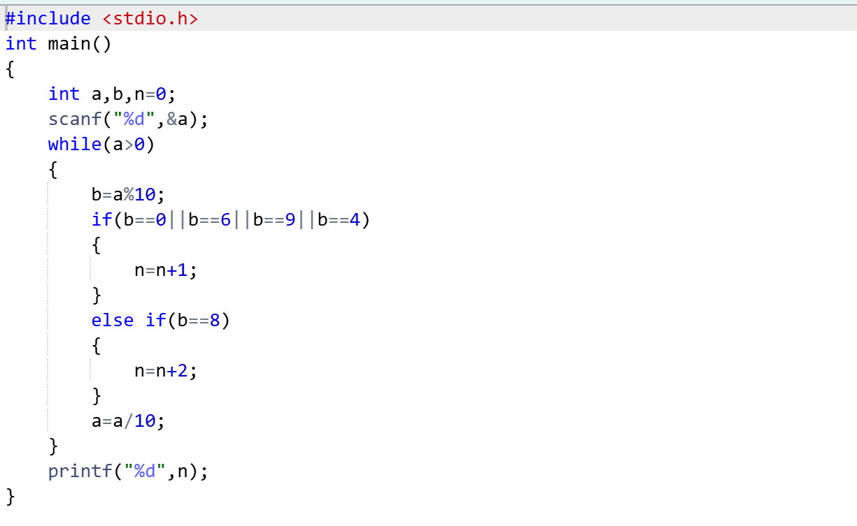

OUTPUT:
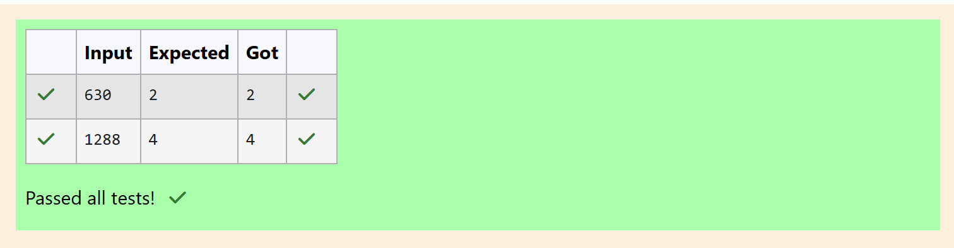

Q3) The problem solvers have found a new Island for coding and named it as Philaland. These
smart people were given a task to make a purchase of items at the Island easier by
distributing various coins with different values. Manish has come up with a solution that if
we make coins category starting from $1 till the maximum price of the item present on
Island, then we can purchase any item easily. He added the following example to prove
his point.
Let’s suppose the maximum price of an item is 5$ then we can make coins of {$1, $2, $3,
$4, $5}to purchase any item ranging from $1 till $5.
Now Manisha, being a keen observer suggested that we could actually minimize the
number of coins required and gave following distribution {$1, $2, $3}. According to him
any item can be purchased one time ranging from $1 to $5. Everyone was impressed with
both of them. Your task is to help Manisha come up with a minimum number of
denominations for any arbitrary max price in Philaland.
Input Format
Contains an integer N denoting the maximum price of the item present on Philaland.
Output Format
Print a single line denoting the minimum number of denominations of coins required.
Constraints
1<=T<=100 1<=N<=5000
Sample Input 1:
10
Sample Output 1:
1
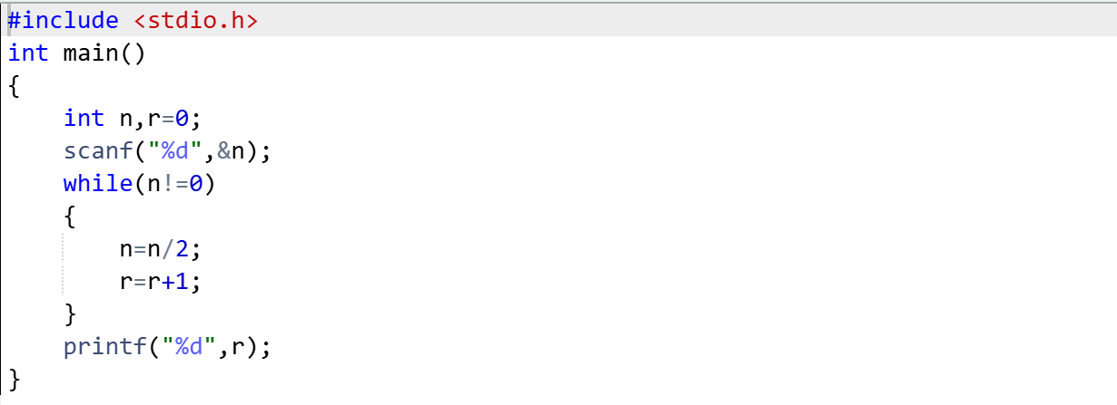
OUTPUT:
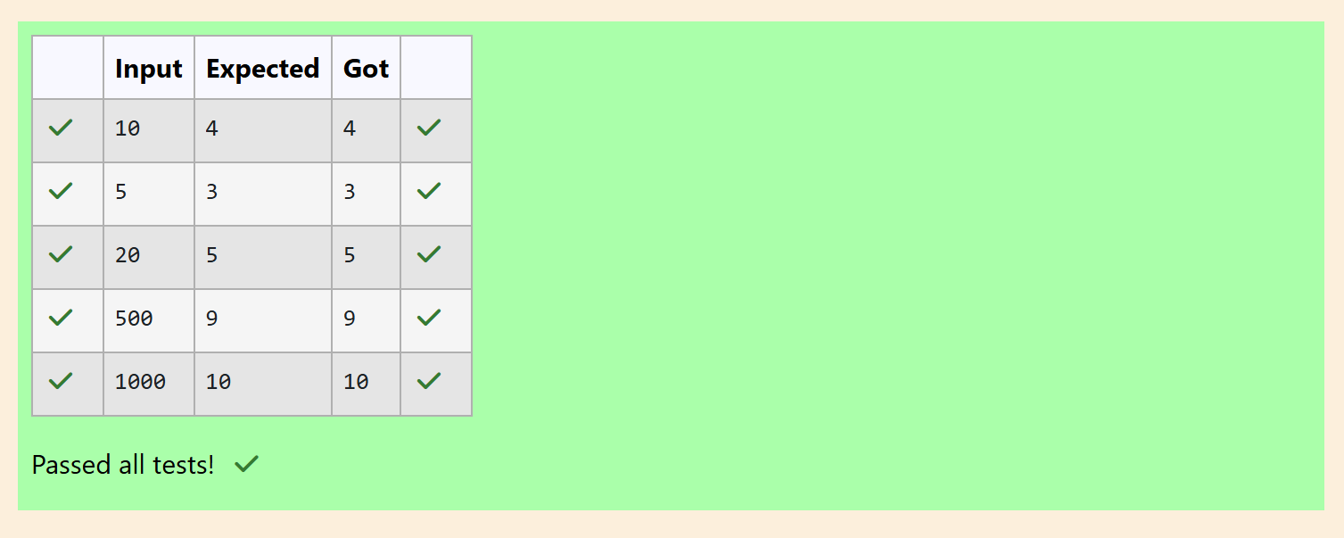

Week: 04-02
ROLL NO.: 241801310
Name: Vidhyashree.J
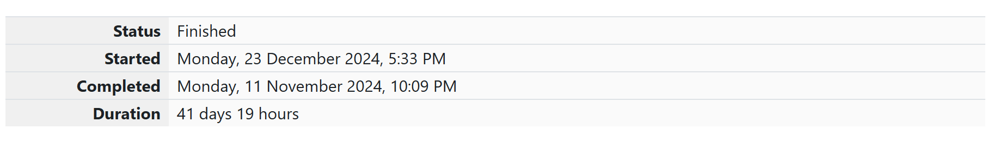
Q1) A set of N numbers (separated by one space) is passed as input to the program. The
program must identify the count of numbers where the number is odd number.
Input Format:
The first line will contain the N numbers separated by one space.
Boundary Conditions:
3 <= N <= 50
The value of the numbers can be from -99999999 to 99999999
Output Format:
The count of numbers where the numbers are odd numbers.
Sample Input:
5 10 15 20 25 30 35 40 45 50
Sample Output:
5
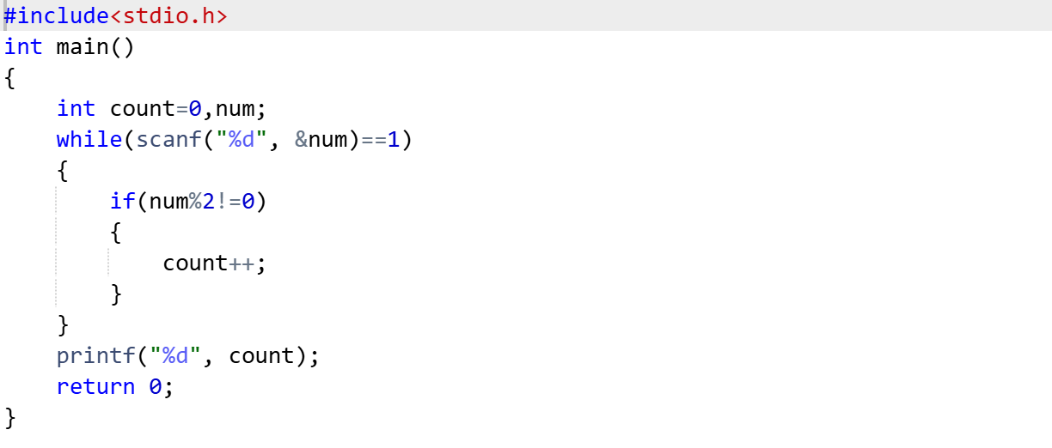

OUTPUT:
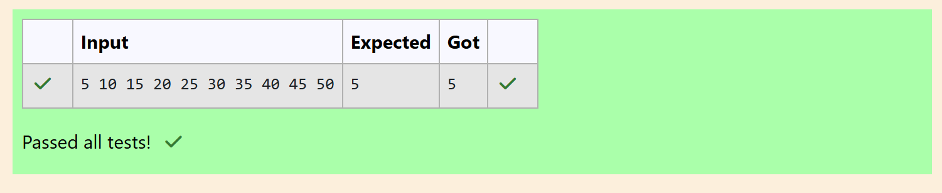

Q2) Given a number N, return true if and only if it is a confusing number, which satisfies the
following condition:
We can rotate digits by 180 degrees to form new digits. When 0, 1, 6, 8, 9 are rotated 180
degrees, they become 0, 1, 9, 8, 6 respectively. When 2, 3, 4, 5 and 7 are rotated 180
degrees, they become invalid. A confusing number is a number that when rotated 180
degrees becomes a different number with each digit valid.
Example 1:
Input: 6
Output: true
Explanation: We get 9 after rotating 6, 9 is a valid number and 9 != 6.
Example 2:
Input: 89
Output: true
Explanation: We get 68 after rotating 89, 86 is a valid number and 86 != 89.
Example 3:
Input: 11
Output: false
Explanation: We get 11 after rotating 11, 11 is a valid number but the value remains the
same, thus 11 is not a confusing number.
Example 4:
Input: 25
Output: false
Explanation: We get an invalid number after rotating 25.
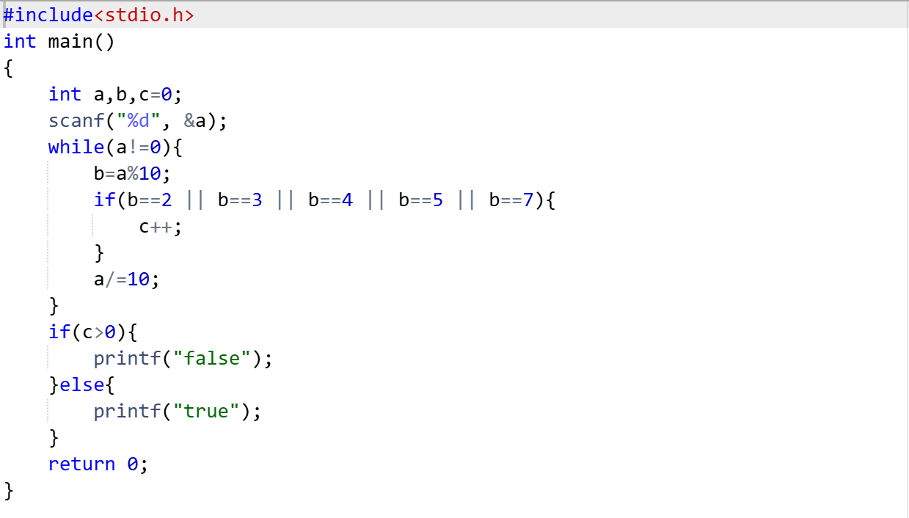
OUTPUT:
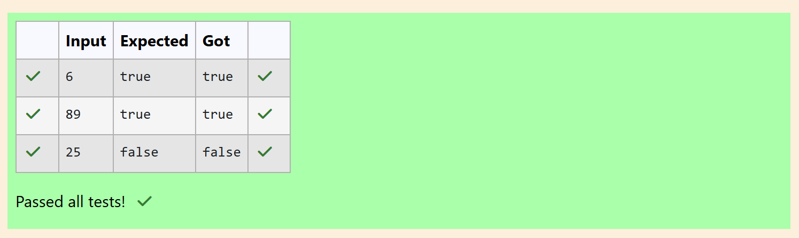

Q3) A nutritionist is labeling all the best power foods in the market. Every food item
arranged in a single line, will have a value beginning from 1 and increasing by 1 for each,
until all items have a value associated with them. An item's value is the same as the number
of macronutrients it has. For example, food item with value 1 has 1 macronutrient, food
item with value 2 has 2 macronutrients, and incrementing in this fashion.
The nutritionist has to recommend the best combination to patients, i.e. maximum
total of macronutrients. However, the nutritionist must avoid prescribing a particular sum
of macronutrients (an 'unhealthy' number), and this sum is known. The nutritionist chooses
food items in the increasing order of their value. Compute the highest total of
macronutrients that can be prescribed to a patient, without the sum matching the given
'unhealthy' number.
Here's an illustration: Given 4 food items (hence value: 1,2,3 and 4), and the
unhealthy sum being 6 macronutrients, on choosing items 1, 2, 3 -> the sum is 6, which
matches the 'unhealthy' sum. Hence, one of the three needs to be skipped. Thus, the best
combination is from among:
• 2 + 3 + 4 = 9
• 1 + 3 + 4 = 8
• 1 + 2 + 4 = 7
Since 2 + 3 + 4 = 9, allows for maximum number of macronutrients, 9 is the right
answer. Complete the code in the editor below. It must return an integer that represents
the maximum total of macronutrients, modulo 1000000007 (109 + 7).
It has the following:
n: an integer that denotes the number of food items
k: an integer that denotes the unhealthy number
Constraints
• 1 ≤ n ≤ 2 × 109
• 1 ≤ k ≤ 4 × 1015
Input Format For Custom Testing
The first line contains an integer, n, that denotes the number of food items. The second line
contains an integer, k, that denotes the unhealthy number.
Sample Input 0
2
2
Sample output 0
3
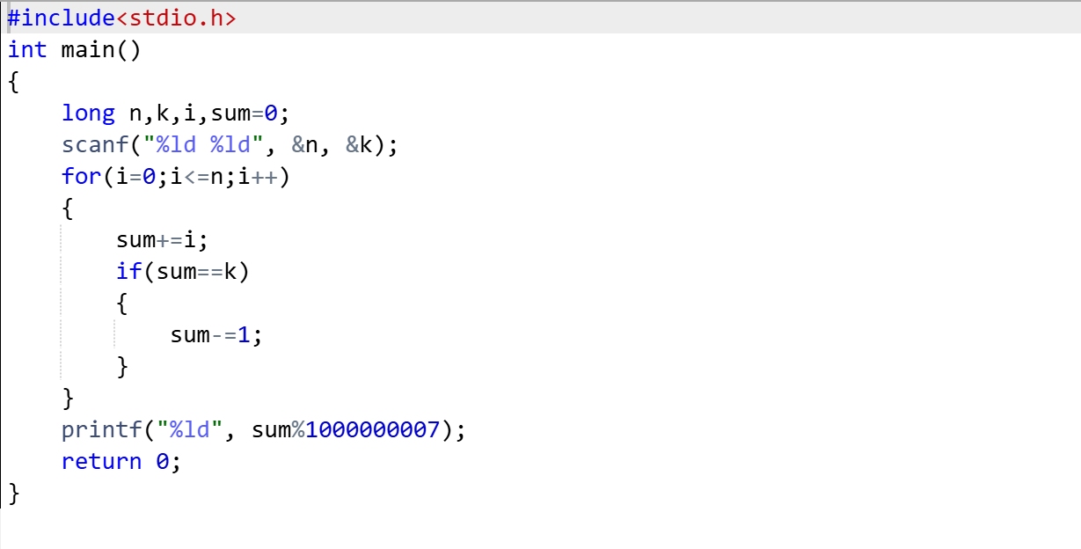
OUTPUT:
